**ASSESSMENT -1**

# **Name:** Ruffina Perlintina IRK

# **Roll no:** 1919102127

# Bar Chart

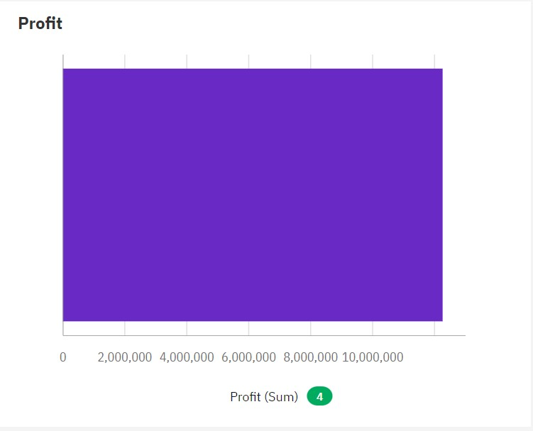

# Radar

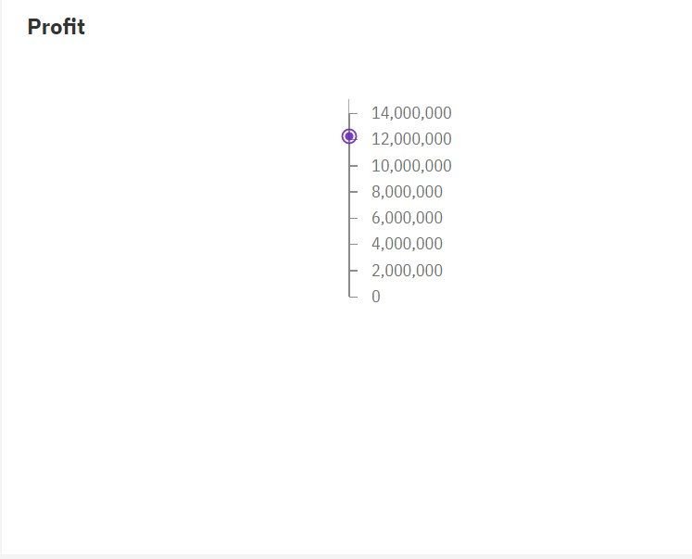

# Heat Map

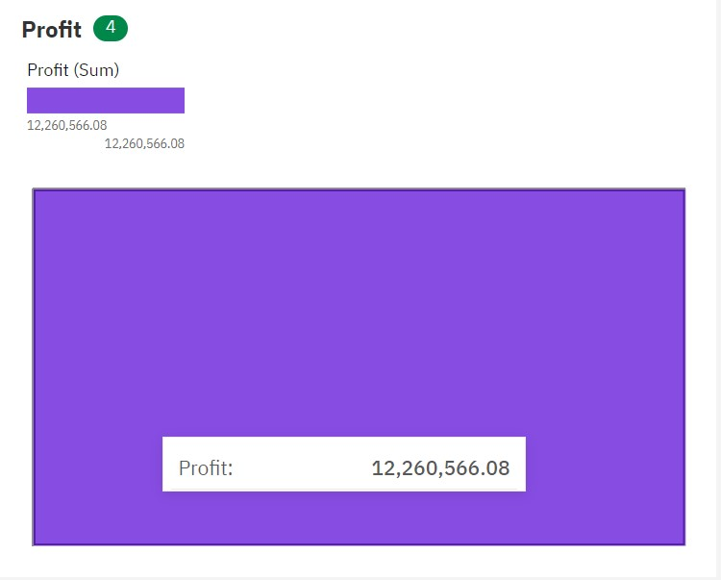

# Radial

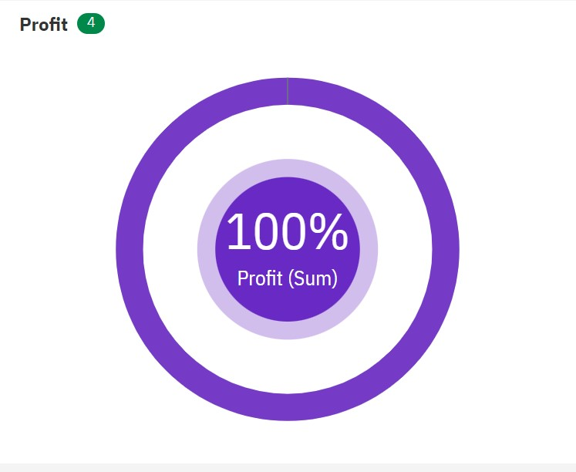

# Marimekko

